EXP 3:
Create a simple cloud software application for Property Buying & Rental process (In Chennai city) using any Cloud Service Provider to demonstrate SaaS
Aim
To design and implement a cloud-based SaaS application for property buying and rental in Chennai using a cloud platform like Amazon Web Services or Google Cloud Platform, enabling users to search, list, and book properties online.
Algorithm
Algorithm: Property Booking System
- Start
- User registers/login
- Display property listings (location, price, type)
- User searches/filter (e.g., Chennai areas like T. Nagar, Velachery)
- User selects property
- Check availability
- If available → proceed to booking
- Store booking details in cloud database
- Send confirmation (email/SMS)
- End
Procedure
- Choose Cloud Provider
Use Amazon Web Services (AWS) or Microsoft Azure
- Frontend Development
  - HTML, CSS, JavaScript (or React)
  - Pages: Home, Search, Property Details, Booking
- Backend Setup
  - Use Node.js / Python (Flask/Django)
  - Handle login, search, booking logic
- Database (Cloud Storage)
  - AWS DynamoDB / Firebase
  - Store user data, property details
- Cloud Hosting
  - AWS EC2 / Firebase Hosting
  - Deploy application online
- Add SaaS Features
  - Multi-user access
  - Subscription or pay-per-use
  - Admin dashboard to manage properties
- Testing
  - Check booking flow
  - Validate search filters
OUTPUT:

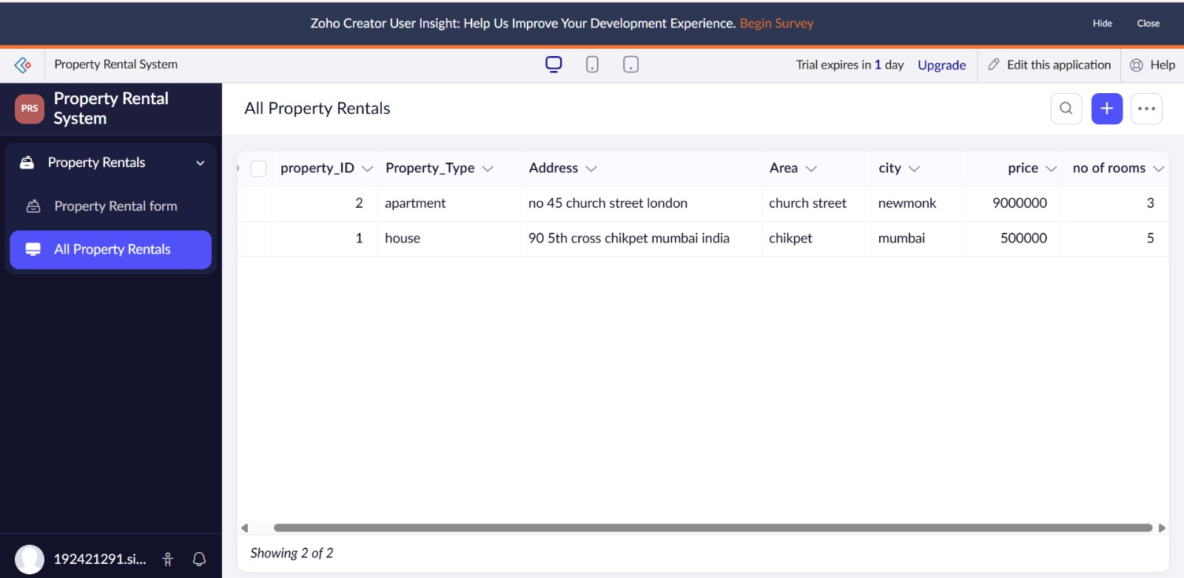

Result
A cloud-based SaaS application is successfully developed where users in Chennai can:
- Search properties
- Book rentals or buy properties
- Access system anytime via internet

